**Alexandra Daddario: wiki | Age** 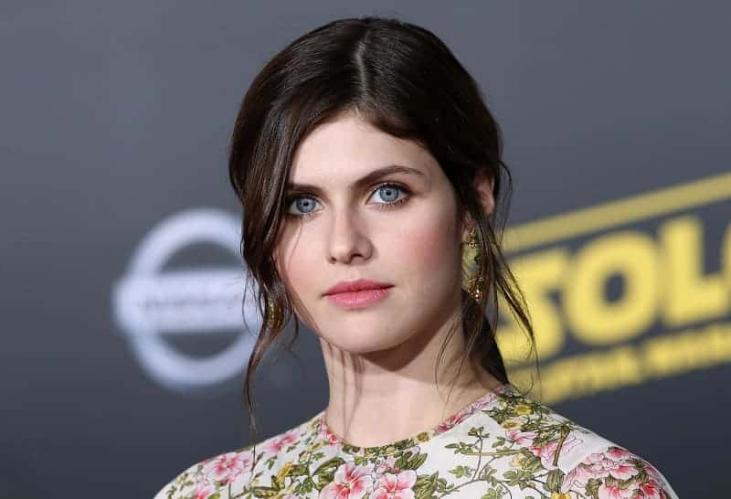

Overview:

|  |  |
| --- | --- |
| Born | March 16, 1986 in NYC, USA |
| Education | Professional Children’s School, Marymount Manhattan College, Brearley School |
| Birth Name | **Alexandra** Anna **Daddario** |
| Nickname | **Alex** |
| ***Height*** | 5’ 8’’ (1.73 m) |
| ***Age*** | 34 years |
| Weight | 124lbs (56 kg) |
| Nationality | USA (United States of America) |
| Religion | Roman Catholic |
| Profession | Actor, Model |
| Years active | 1998 - present |
| Parents | Richard C. Daddario (*father*), Christina Titus (*Mother*) |
| Relatives | **Matthew Daddario** (*brother)*, **Catharine Daddario** (*sister*), **Emilio Q. Daddario** (*Grandfather*) |
| Trade mark | Extremely bold **blue eyes** |
| Famous Works | **Percy Jackson film series**, **San andreas**, **Baywatch**, Can you keep a secret? , We summon the Darkness, etc. |
| Followers on **Instagram** | 18.6 million |
| **Boyfriend** | **Husband** | Marital status | Single as of now |
| **Net Worth** | $8 million |

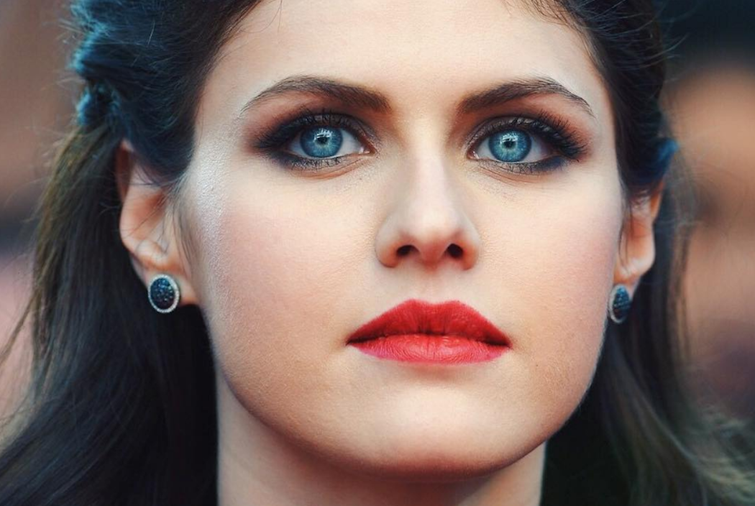

**Alexandra** Anna **Daddario**, an *American actress* born on March 16, 1986 in NYC, New York, USA, to Richard Daddario, a prosecutor, and Christina, a lawyer by profession. Her sister is actor **Catharine Daddario**, her brother is actor **Matthew Daddario**, and her grandpa was **Emilio Q. Daddario**, a congressman of Connecticut. She kind of hails from different parentage. She has *Irish, Italian, Slovak/Hungarian* descent. She had the dream to be an actress since her childhood and she got her first work at the age of 16 as “Laurie Lewis” in All My Children(1970). She’s known for her roles in Percy Jackson film series, San Andreas, Can you keep a secret? and many more.

Some of her famous works include the role of Annabeth Chase in the Percy Jackson movies, Percy Jackson And the Lightning Thief (2010), Percy Jackson: Sea of Monsters (2013), role of Blaike Gaines in quake film San Andreas (2015), and she appeared on many more films and Television series and some of the predominant one among those are It’s always Sunny in Philadelhia (2005), White Collar (2009), American Horror Story (2011): Hotel, Hall Pass (2011), Texas Chainsaw (2013), True Detective (2014), Baywatch (2017)

She’s known for her roles and her extremely bold blue eyes. Her mother has *Slovak, English, Hungarian*, and *German* origin while her father, Richard C. Daddario has 25% *Irish* and 75% *Italian* ancestry. So, she’s kinda blend of these descents. She’s ranked *#80 on Maxim’s “Hot 100” of 2014* list. She’s one of the most famous actress among the youngsters with a whooping fan following of over 18 million on Instagram. 1 Night in San Diego (November, 2020) and Songbird (December, 2020) are her latest works. To know more about her, stay tuned to us!